**User Manual**

**1. Steps to Run the Code**

Open two terminals.

**Terminal One – Client Side:**

1. cd client\authapp

2. npm install

3. npm run dev

**Terminal Two – Server Side:**

1. cd server

2. npm install

3. nodemon

**Login Credentials**

**1. Student**

Username: student@dundee.ac.uk

Password: 1234

**2. Staff**

Username: staff@dundee.ac.uk

Password: 5678

**3. Admin**

Username: admin@dundee.ac.uk

Password: 9876

**Note:**

1. The email feature in the timesheet system will not send an email successfully as the user has to use his/her personal email address and password during login.

**2. Description of The Final Product**

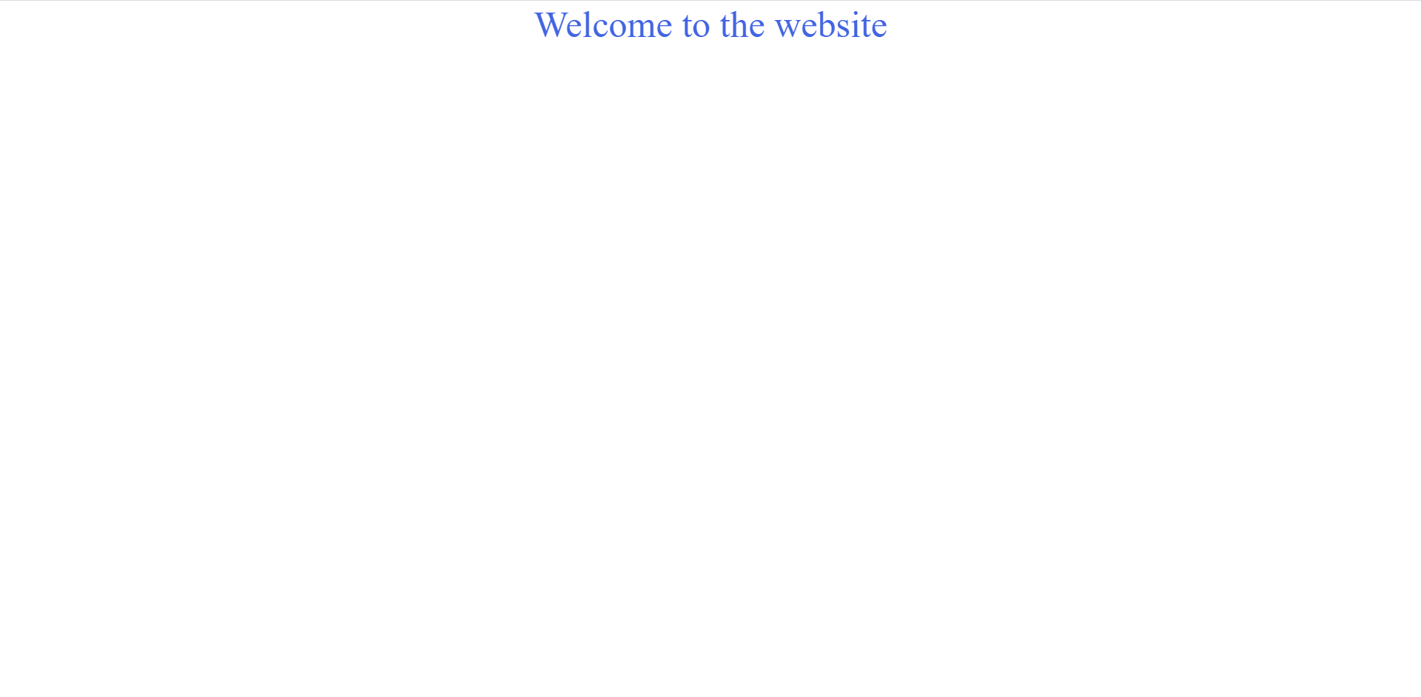1. The user will gain access to the timesheet system through the starting page [See Figure 1].

Figure 1 - Starting Page

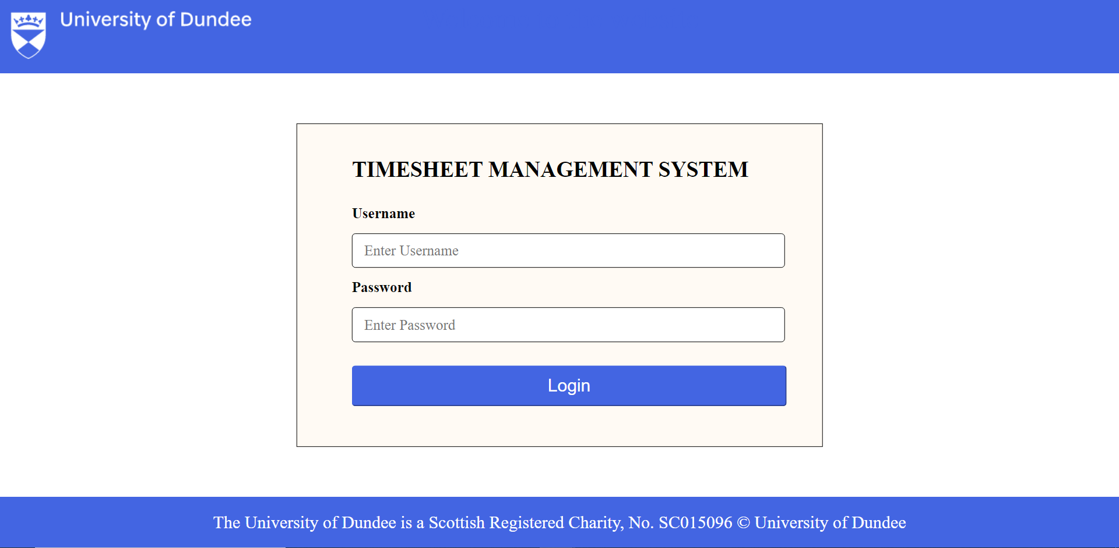2. After clicking the text welcome to the website, the user will be redirected to the login page [See Figure 2].

Figure 2 - Login Page

3. If the username and password entered by the user match with the username and password in the database table, the login page will be redirected to the subsequent page. The redirection will be based on the user's role, either student, staff, or admin.

**Student**

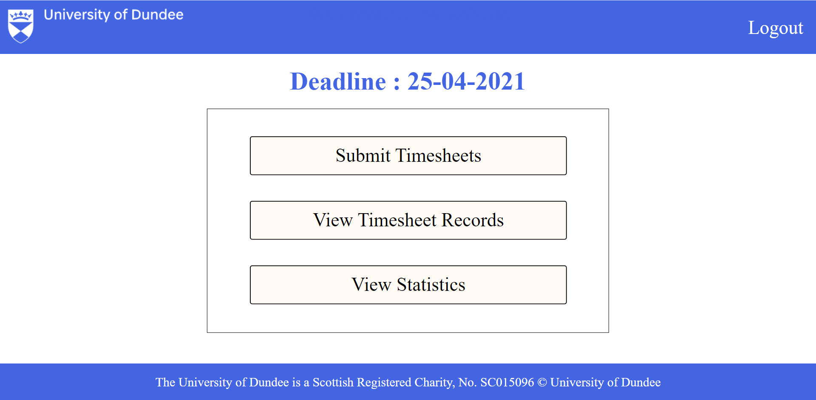4. On the student dashboard page [See Figure 3], there is a deadline to submit timesheets and three options: submit timesheet, view timesheet records, and view statistics. Out of the three, view timesheet records and view statics are still under development.

Figure 3 - Student Dashboard Page

5. When the user clicks the text submit timesheet, the user will be redirected to the submit timesheet page [See Figure 4]. On this page, the user will have to input the week, date, day, the number of hours worked on that particular day, submission date, and choose a job role and module from the dropdown menus.

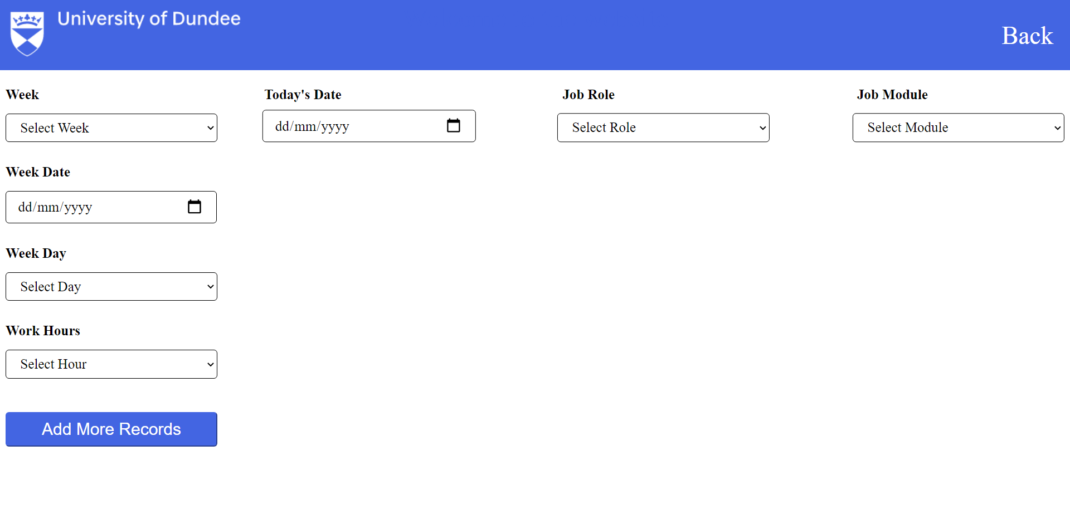Figure 4 - Submit Timesheet Page

**Staff**

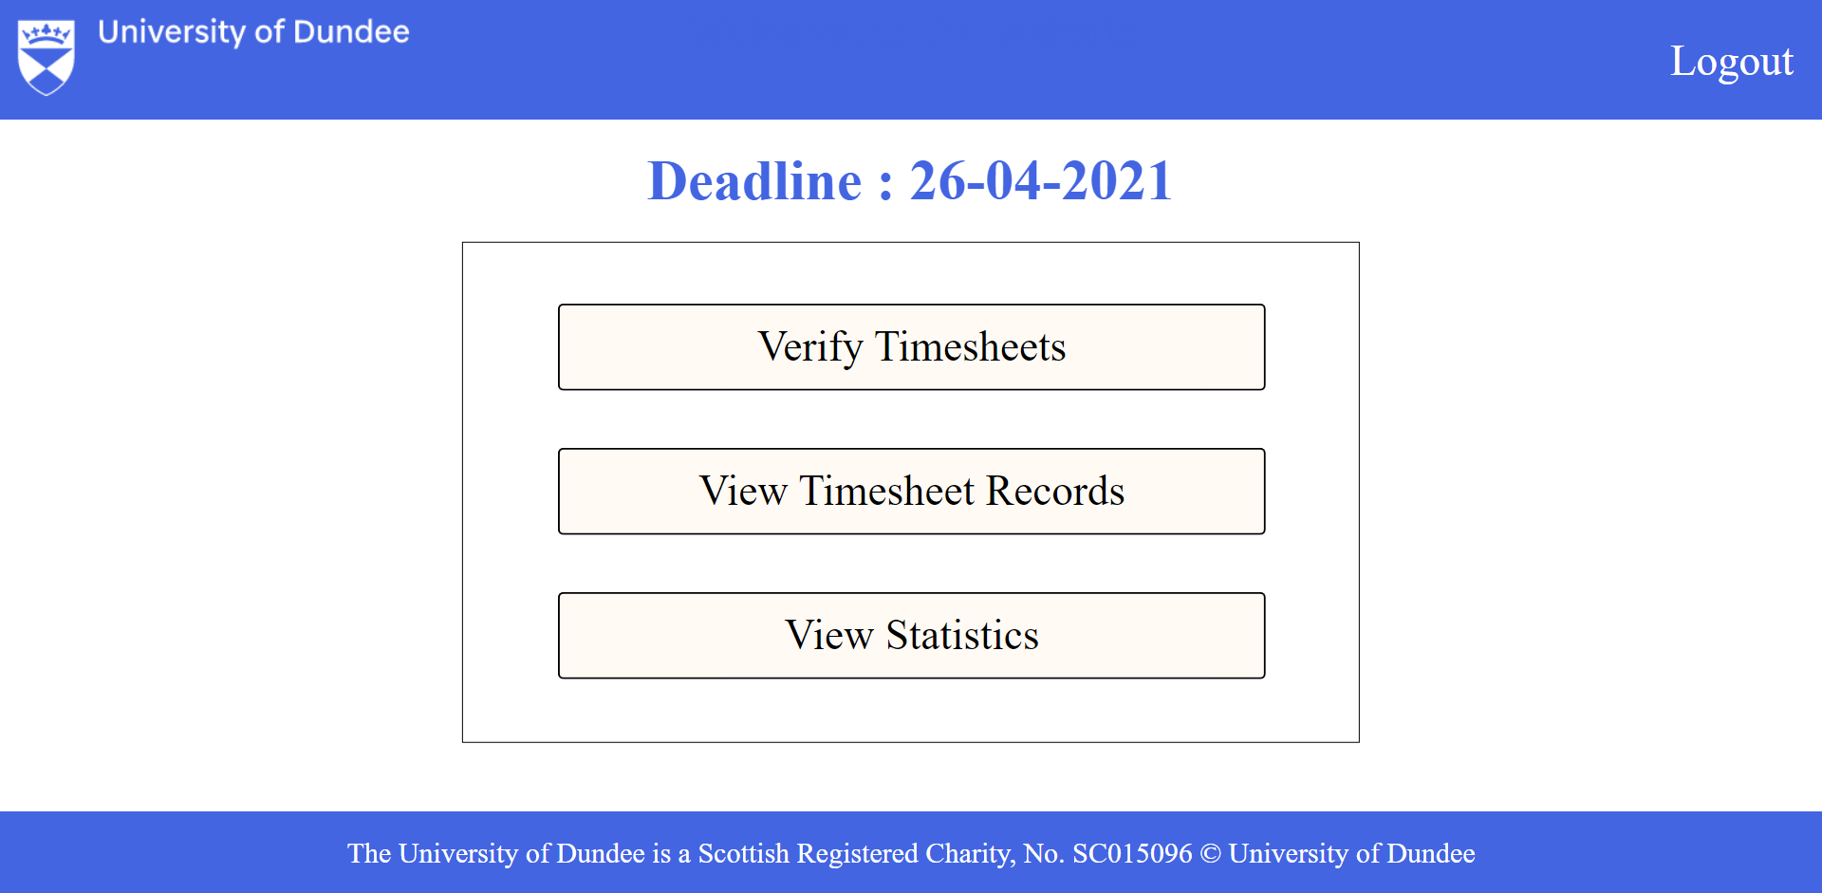6. On the staff dashboard page [See Figure 5], there is a deadline to verify timesheets and three options: verify timesheet, view timesheet records, and view statistics. Out of the three, view timesheet records and view statics are still under development.

Figure 5 - Staff Dashboard Page

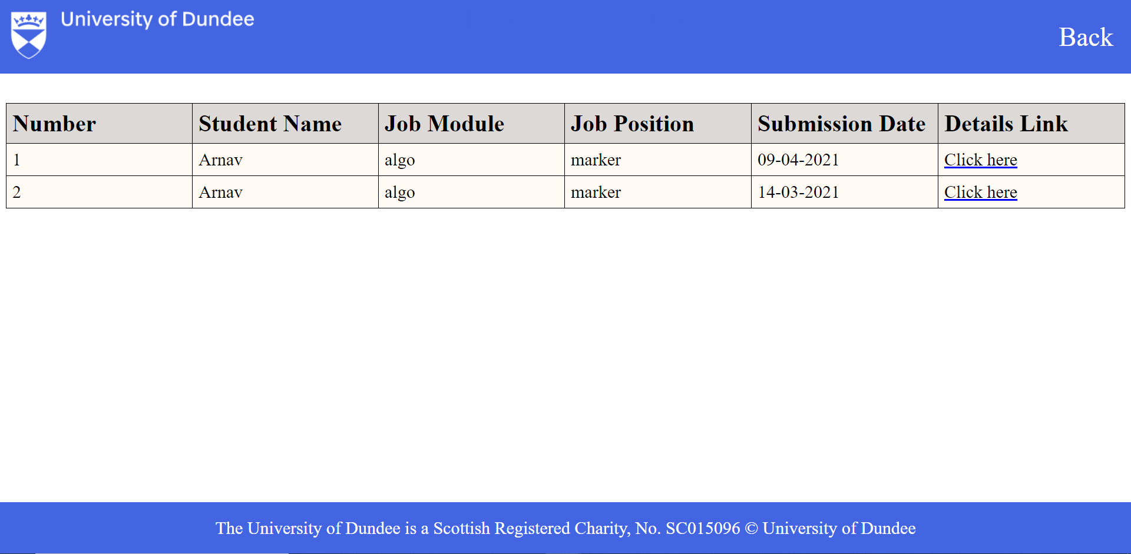7. When the staff clicks the text verify timesheet, the user will be redirected to the verify timesheet table page [See Figure 6]. On this page, data will be displayed in a table format. The data will consist of employee name, job module, job role, and submission date.

Figure 6 - Verify Timesheet Table Page

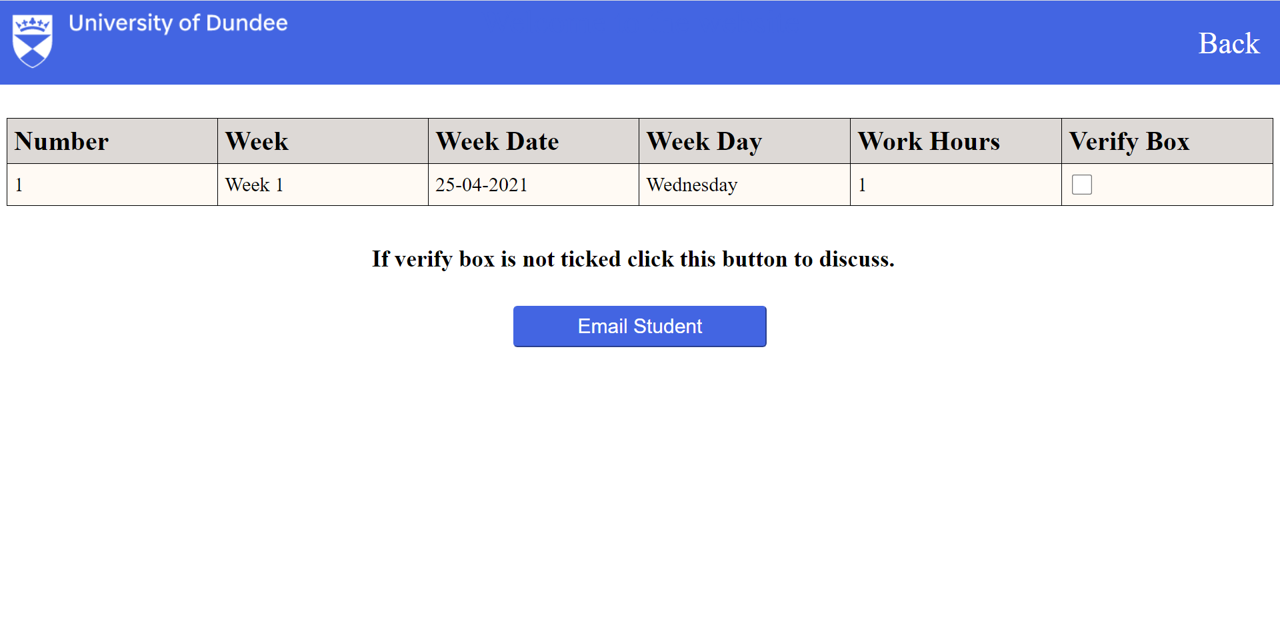8. The staff can click the text click here of any row, and the verify timesheet table page will be redirected to the verify timesheet details page [See Figure 7]. On this page, information will be displayed in a table format. The information will consist of the week, date, day, and the number of hours worked on that particular day.

Figure 7 - Verify Timesheet Details Page

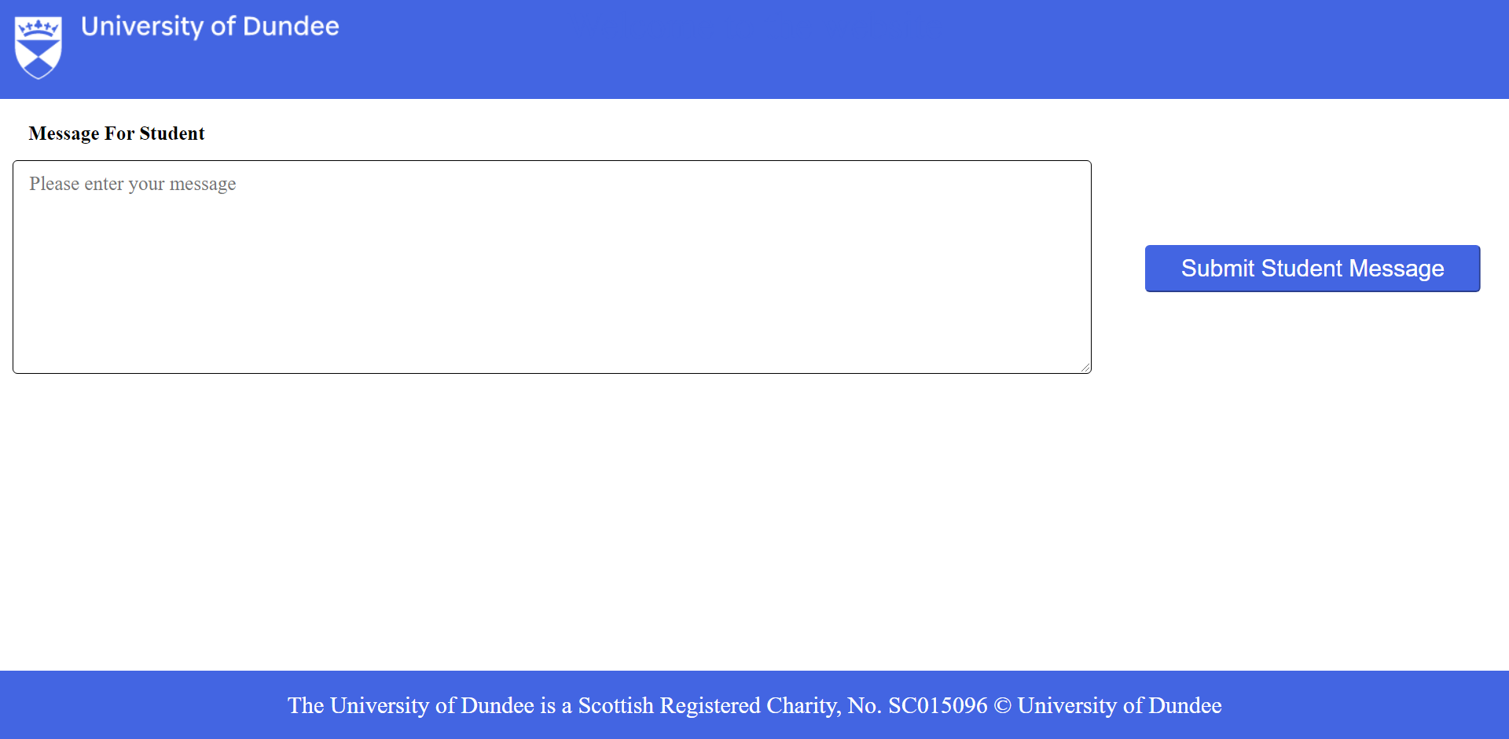9. If not all the verify boxes are ticked, the staff will have to click the text email student. The verify timesheet details page will be redirected to the verify timesheet email page [See Figure 8]. This is a page where the staff can send an email message to notify the student regarding the timesheet information.

Figure 8 - Verify Timesheet Email Page

**Admin**

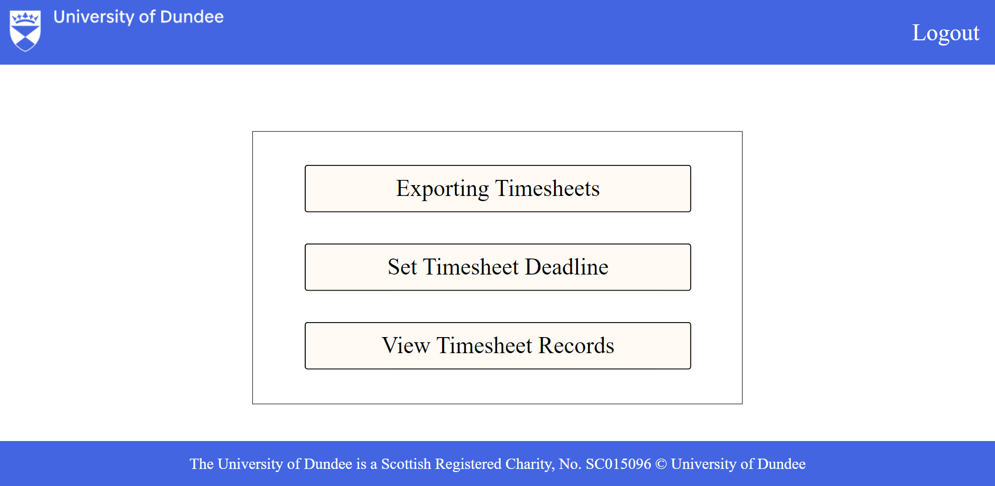10. On the admin dashboard page [See Figure 9], there are three options: exporting timesheets, set timesheet deadline, and view timesheet records. Out of the three, view timesheet records are still under development.

Figure 9 - Admin Dashboard Page

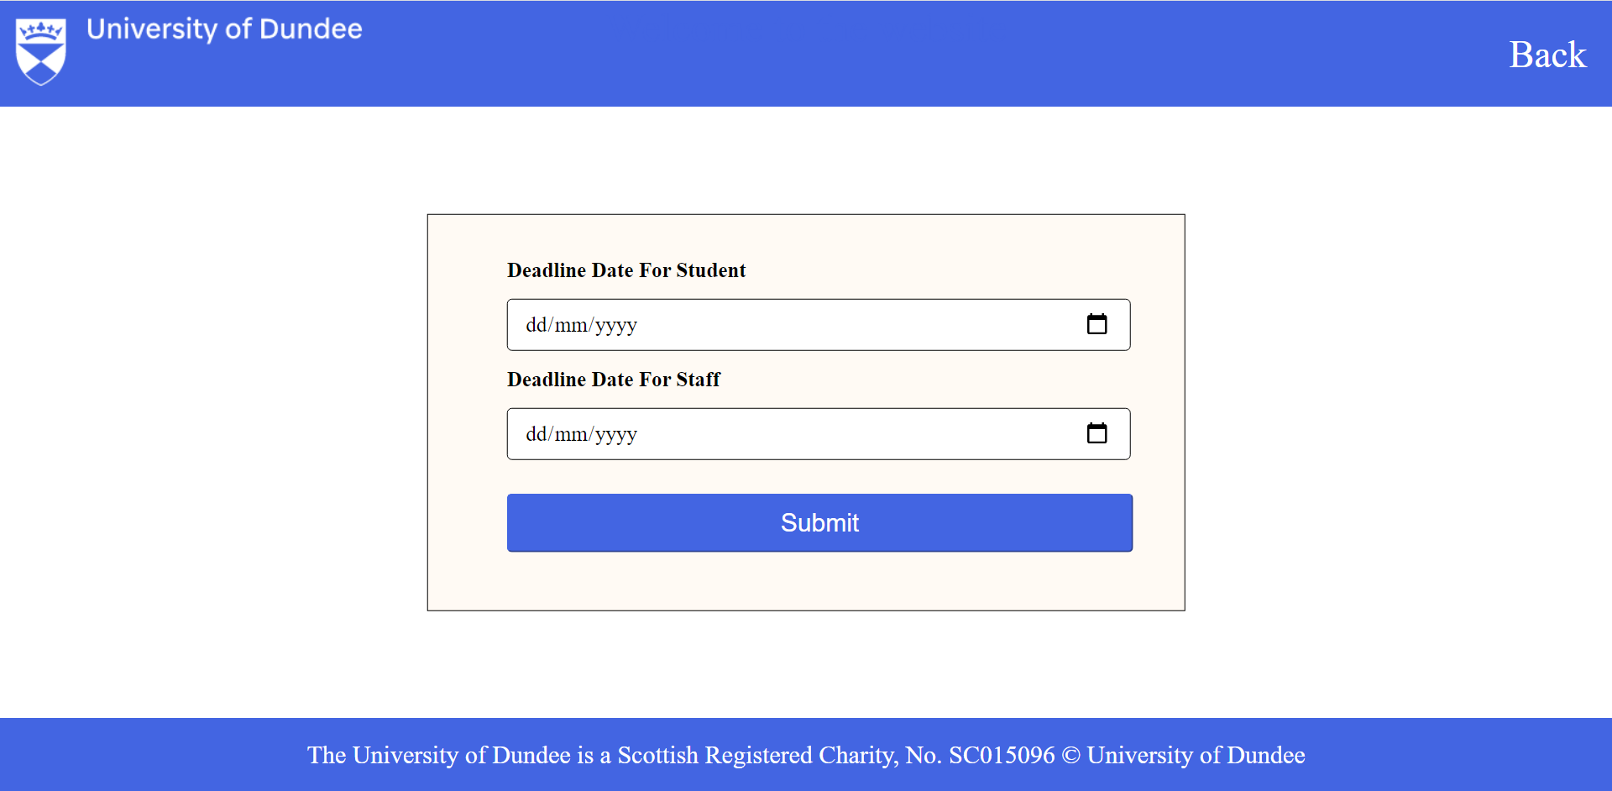11. When the staff clicks the text set timesheet deadline, the user will be redirected to the set timesheet deadline page [See Figure 10]. On this page, the admin will have to input deadline date for students and staff.

Figure 10 - Set Timesheet Deadline Page

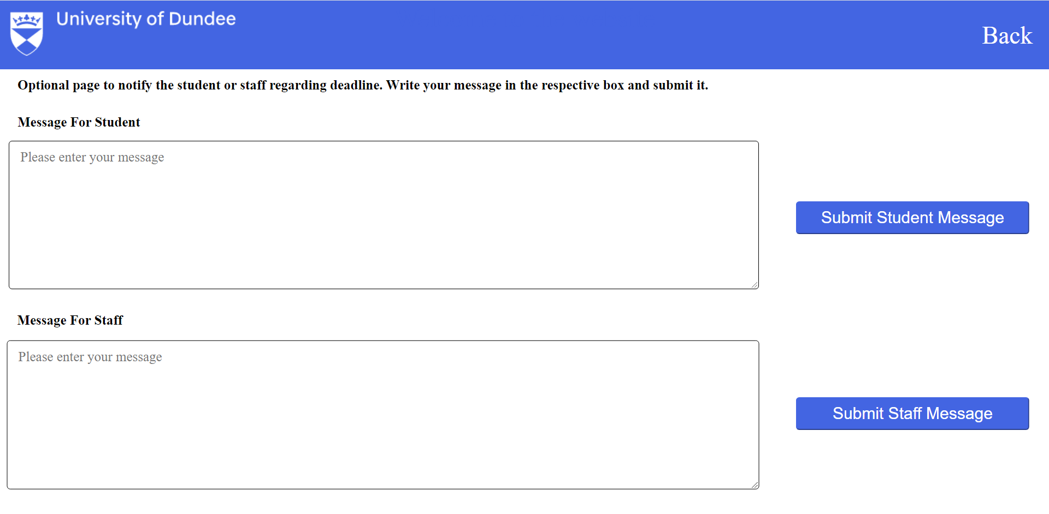12. After submitting the dates, the admin dashboard page will be redirected to the deadline email page [See Figure 11]. This is an optional page where the admin can send an email message to notify the students and staff regarding the deadline dates.

Figure 11 - Deadline Email Page

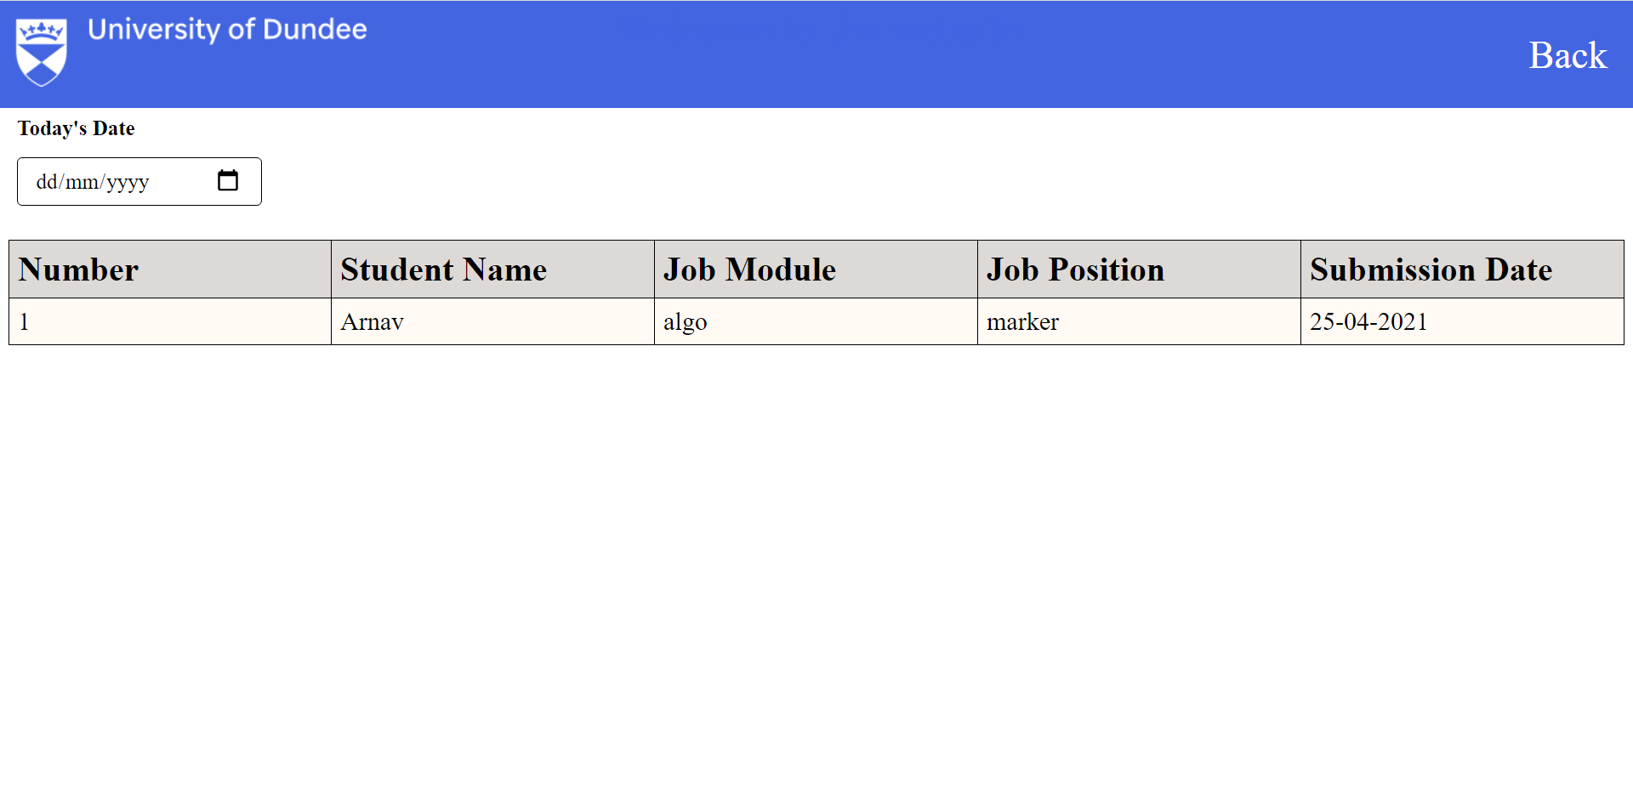13. When the staff clicks the text exporting timesheets, the admin will be redirected to the export timesheet page [See Figure 12]. On this page, data will be displayed in a table format. The data will consist of employee name, job module, job role, and submission date. Apart from that, the admin will have to input the date of export.

Figure 12 - Export Timesheet Page

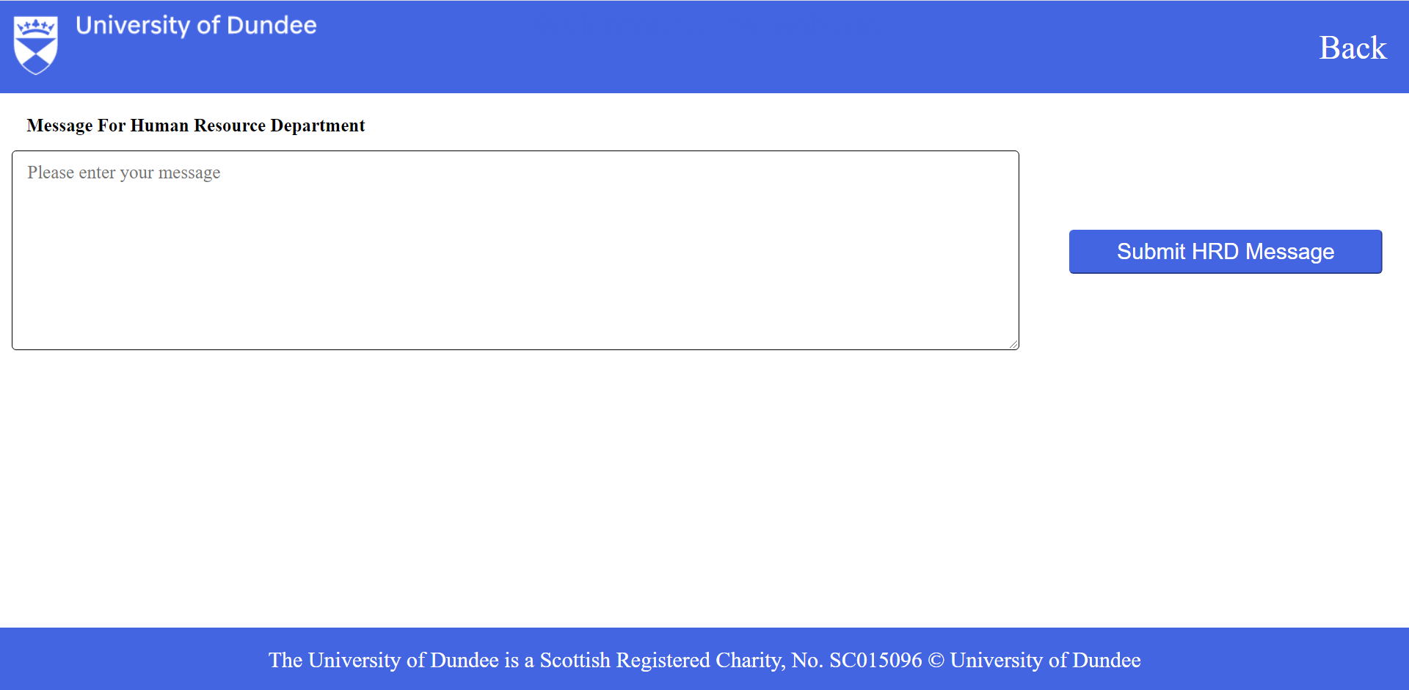14. After submitting the date, the export timesheet page will be redirected to the export timesheet email page [See Figure 13]. This is a page where the admin can send an email message and attach the pdf document to notify the University Human Resource Department regarding the timesheets.

Figure 13 - Export Timesheet Email Page